# Lab 09

Instructor: Sidra Khatoon E-mail: skhatoon[@uit.edu](mailto:ad@uit.edu)

# Objective

# The objective of lab is exploring inkwell widgets and its usages.

**Student Information**

|  |  |
| --- | --- |
| **Student Name** |  |
| **Student ID** |  |
| **Date** |  |

**Assessment**

|  |  |
| --- | --- |
| **Marks Obtained** |  |
| **Remarks** |  |
| **Signature** |  |

# Objective

# The objective of lab is exploring inkwell widgets and its usages

# Instructions

You have to perform the following tasks yourselves. Raise your hand if you face any difficulty in understanding and solving these tasks. **Plagiarism** is an abhorrent practice and you should not engage in it.

# How to Submit?

Submit lab work using Teams.

**ListTile Widget**

The ListTile widget in Flutter is a UI element that displays related information. It follows the List specification from Material Design. A typical ListTile is divided into three sections; Start, Center, and End. The Start section contains the leading widget; the Center section includes the title and subtitle, and the End section contains the trailing widget.

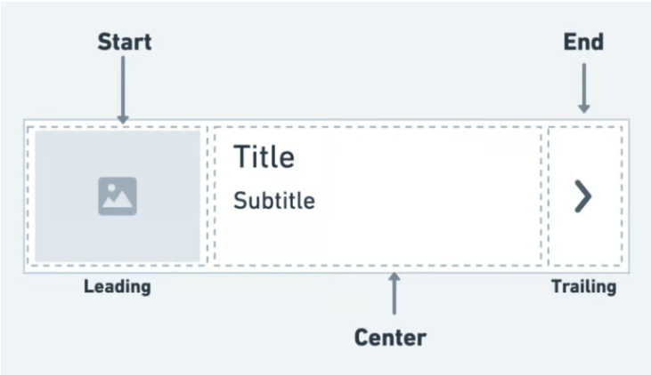

It is mainly used to populate the scrollable views such as ListView, Column, and Row. For example, you can use the ListTile to show a list of to-do items, emails, navigation options, and more. You can also receive the click event by tapping the ListTile.

**Adding ListTile**

Here is the minimal code to display ListTile inside the ListView widget:

When you want to use the ListTile to populate the long list that might come from your backend, you can wrap the single ListTile widget inside the ListView.Builder and show the data inside the ListTile, as shown in the following code:

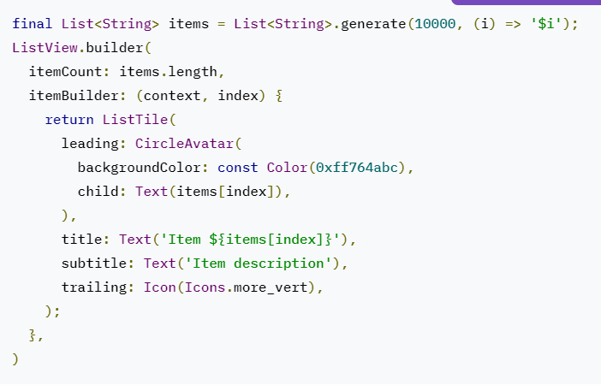

**ListTile variations**

There are also other types of ListTile that exist that allow you to perform a specific action on it.

These are:

1. CheckboxListTile
2. RadioListTile
3. SwitchListTile

**CheckboxListTile:**

The CheckboxListTile widget is a combination of ListTile and Checkbox widgets. We can use this widget to mark any item as complete — for example; to-do items. By default, the checkbox is displayed on the right side of the ListTile (for left-to-right language).

**RadioListTile**

The RadioListTile widget is a combination of ListTile and RadioButton widgets — this widget is

used to select a single option from a list of items.

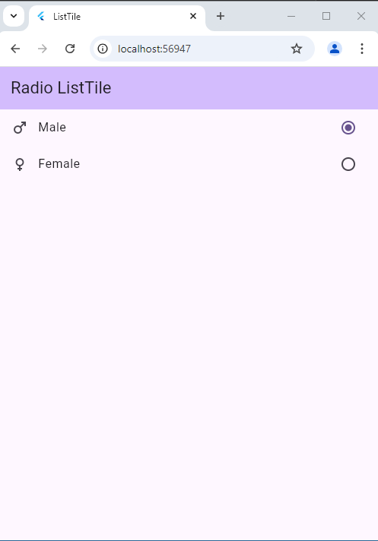

**SwitchListTile**

The SwitchListTile widget is a combination of the ListTile and Switch widgets. We can use this widget to

build the UI interaction that allows users to switch on or off app settings.

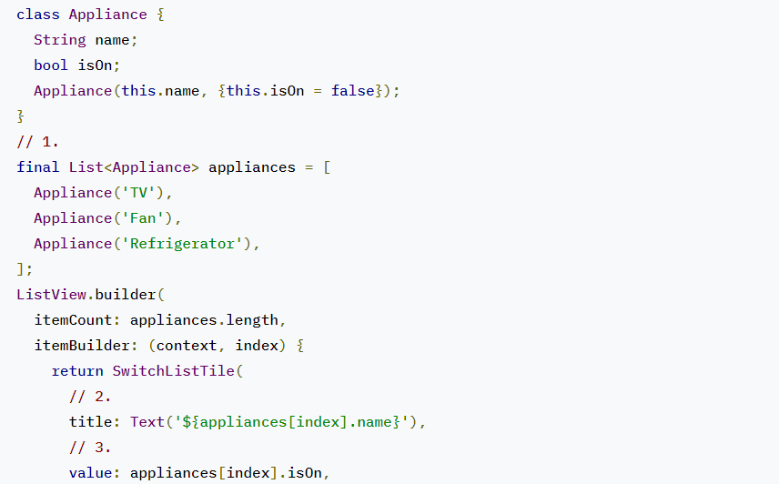 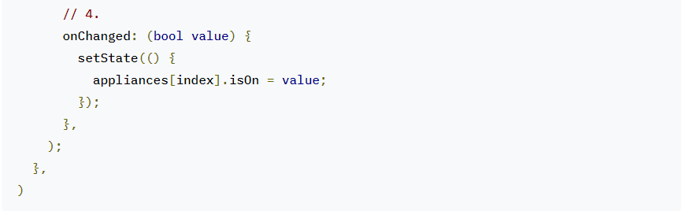

**Assessment**

**Task:** Set up a new Flutter project named ContactsApp using your preferred development

environment.

* Use ListView**.Builder** to dynamically generate a list of contacts.
* Implement a **ListTile** for each contact, displaying the contact’s name and phone number.
* Add an avatar (using **Icon**) and a trailing icon (phone icon) for each contact.